##### INVENTORY MANAGEMENT

###### ***Submitted by***

**IMMANUEL RAJKUMAR**

**PGDMB16-058**

***In partial fulfillment for the award of the degree of***

**POST GRADUATE DIPLOMA IN MANAGEMENT**



**INSTITUTE FOR FINANCIAL MANAGEMENT AND RESEARCH**

**5655, Central Express Way, Sector 24, Sri City, Andhra Pradesh**

**2016**

**CERTIFICATE**

This is to certify that this project report “**Inventory Management” is** the bonafide work of **Immanuel Rajkumar,** PGDMB16-058of **Institute for Financial Management and Research** doneunder my supervision from 01.04.2016 to 31.05.2016

**Date: 31.05.2016**

**Place: Sri City (Signature)**

**ACKNOWLEDGEMENT**

I convey my sincere thanks to my project guide at the institute Dr. Ramkumar, project guide at the company Mr. Ramprasad, plant manager Mr. Suresh Nimonkar, project co-ordinators Mr. Senthil, Mr. Baskaran, Mr. Srinivas Murthy and Mr. Prabhu Kiran. I extend my thanks to all the staff of Colgate Palmolive, Sri City.

Signature

Name of the student

**EXECUTIVE SUMMARY**

The internship assignment is broadly classified into two projects. The projects are ‘Inventory optimization in the engineering store using ABC analysis’ and ‘Regulating the control of inward material movement into the factory’. There were nearly 2500 spare items in the inventory store costing around Rs. 2.5 crore. We classified those items into A, B and C items according to their movement, value, and volume. Thereby we were able to reduce the inventory holding cost considerably. The second project is to regulate the control of inward material movement by calculating the delay between Inward Register date and Goods Receipt date. We found that 10.36% of the items having a delay of two or more than two days. Apart from these projects, I also prepared training module on ‘Income Statement’ and skill mapping of the employees in the production. The training module on income statement is targeted for audience in shop floor who have only basic knowledge on Finance. I also performed a short assignment on ‘Skill mapping of operators and technicians in the shop floor’ which was used by the Human Resources for internal use.

**TABLE OF CONTENTS**

|  |  |  |
| --- | --- | --- |
| **Chapter No** | **Title** | **Page Number** |
|  | **Executive Summary** | **i** |
|  | **List of Tables** | **ii** |
| **1** | **Introduction** | **6** |
| **2** | **Project on ABC Analysis of Inventory Items** | **8** |
| **3** | **Project on Inward Material Movement** | **10** |
| **4** | **Annexure 1** | **13** |

**Colgate Palmolive Global:**

Colgate-Palmolive Co. is a global consumer products company that is focused on Oral Care, Personal Care, Home Care and Pet Nutrition. The company sells its products around the world under brand names such as Colgate, Palmolive, Mennen, Speed Stick, Lady Speed Stick, Softsoap, Irish Spring, Protex, Sorriso, Kolynos, elmex, Tom's of Maine, Sanex, Ajax, Axion, Fabuloso, Soupline and Suavitel, as well as Hill's Science Diet and Hill's Prescription Diet. The company operates its business in two product segments: Oral, Personal and Home Care; and Pet Nutrition.

The Oral, Personal and Home Care segment is operated through four reportable operating segments: North America, Latin America, Europe/South Pacific and Greater Asia/Africa, all of which sell to a variety of retail and wholesale customers and distributors. Its Oral Care products include Colgate Total, Colgate Sensitive Pro-Relief, Colgate Max Fresh, Colgate Optic White and Colgate Luminous White toothpastes, Colgate 360° manual toothbrushes and Colgate and Colgate Plax mouth rinses. Its Oral Care business also includes dental floss and pharmaceutical products for dentists and other oral health professionals. It manufactures and markets a wide array of products for Home Care, including Palmolive and Ajax dishwashing liquids, Fabuloso and Ajax household cleaners and Murphy's Oil Soap. Its Personal Care products also include Palmolive, Softsoap and Sanex brand shower gels, Palmolive, Irish Spring and Protex bar soaps and Speed Stick, Lady Speed Stick and Sanex deodorants and antiperspirants. Its Personal Care business outside the U.S. includes Palmolive and Caprice shampoo and conditioners.

The company, through its Hill's Pet Nutrition segment, provides specialty pet nutrition products for dogs and cats. It markets pet foods primarily under two trademarks: Hill's Science Diet and Hill's Prescription Diet.

**Colgate Palmolive India:**

Colgate Palmolive (India) Limited is an India-based company that is engaged in the personal care and oral care business. The Company's personal care products include soaps, cosmetics, toilet preparations, body wash, liquid hand wash, skin care and hair care, among others. The Company's oral care products include toothpastes, toothbrushes, toothpowder, whitening products and mouthwash. The Company's household care product includes surface care. Its portfolio of products includes Colgate Sensitive Pro-Relief (CSPR) Enamel Repair Toothpaste, Colgate Visible White Plus Shine Toothpaste, Colgate SlimSoft Charcoal Toothbrush, Colgate ZigZag Black Toothbrush, Colgate Plax Active Salt Mouthwash and Colgate Active Salt Neem, among others. The Company has set up manufacturing facilities in the following cities.

1.      Aurangabad, Maharashtra

2.      Baddi, Himachal Pradesh

3.      Kundaim, Goa

4.      Sanand, Gujarat

5.      Sricity, Andhra Pradesh

**Colgate Palmolive Sri City:**

Colgate-Palmolive (India) Limited has inaugurated its first ever [toothbrush](http://www.business-standard.com/search?type=news&q=Toothbrush)production unit of India in [Sri City](http://www.business-standard.com/search?type=news&q=Sri+City)on 03rd Feb, 2016. The plant was set up with an initial capacity to produce 220 million pieces of tooth brushes a year, at an investment of Rs 450 crore. The company has recently signed a [MoU](http://www.business-standard.com/search?type=news&q=Mou)with Andhra Pradesh government to invest an additional Rs 450 crore for expanding the operations at Sri City, a large private business and industrial park located near Tamil Nadu borders. The company proposes to expand the unit for increasing the annual production capacity to 600 million pieces of toothbrushes in future. The present unit was commissioned in a building of 16,000 square meter area in 19 months, which was built in a 25 acre land acquired by the company in Sri City.

**INVENTORY OPTIMISATION USING ABC ANALYSIS:**

Objective:

To categorize the spare items in the engineering stores into critical, less critical and non-critical based on their movement, value and volume.

Scope:

1. A questionnaire is prepared and the responses of the concerned personnel in the engineering stores are noted. Questionnaire is attached in Annexure 1
2. Data of movement, value and volume of each of the spare item is collected from the company’s SAP record.
3. Weights allotted to each of the above criterion and then the grouping of inventory is obtained.

ABC Analysis:

ABC analysis is an inventory categorization method which consists in dividing items into three categories (A, B, C):

1. A being valuable items
2. B being less valuable items
3. C being least valuable items

This method aims to draw managers’ attention on the critical few (A-items) not on the trivial many (C-items).

VILFREDO PARETO (1848-1923)

He introduced the concept of [Pareto efficiency](https://en.wikipedia.org/wiki/Pareto_efficiency) and helped develop the field of microeconomics. The [Pareto principle](https://en.wikipedia.org/wiki/Pareto_principle) was named after him and built on observations of his such as

1. 20% of population owns 80% of nations wealth
2. 20% of employees cause 80% of problems
3. 20% of items accounts for 80% of firms expenditure

The ABC approach states that a company should rate items from A to C, basing its ratings on the following rules:

1. A-items are goods which annual consumption value is the highest; the top 70-80% of the annual consumption value of the company typically accounts for only 10-20% of total inventory items.
2. B-items are the interclass items, with a medium consumption value; those 15-25% of annual consumption value typically accounts for 30% of total inventory items.
3. C-items are, on the contrary, items with the lowest consumption value; the lower 5% of the annual consumption value typically accounts for 50% of total inventory items.

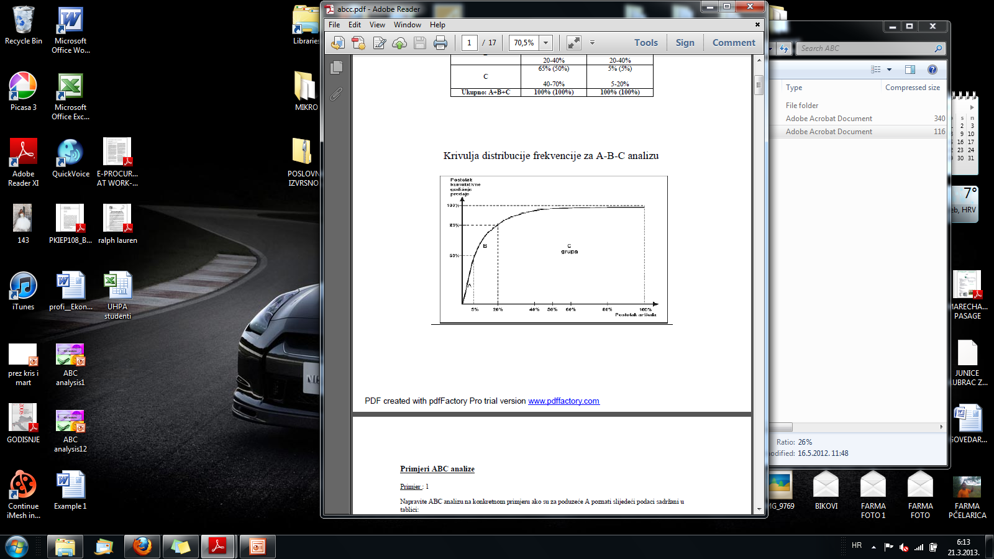

Observation:

|  |  |  |  |  |
| --- | --- | --- | --- | --- |
| **Stock & Non Stock** | |  | **Spare Criticality** | |
| Stock Items | 1318 |  | A Criticality | 292 |
| Non Stock | 1186 |  | B Criticality | 1359 |
|  |  |  | C Criticality | 853 |
| **Total** | **2504** |  | **Total** | **2504** |

**CONTROL OF INWARD MATERIAL MOVEMENT:**

Objective:

To ascertain whether all the controls are in place while inward movement of materials.  
Scope:

* The process of recording the document details in the Security register at the gate.
* The GR report at Engineering Stores and Warehouse location.
* The samples taken were for the month of April 2016.

Procedure:

We compared the GR report with the Security register to ascertain whether the GR are being recorded within the same date of receipt of material.

Observation:

1. Our review of material movement reveals that, adequate controls are in place except for few of the observations as stated in Table 1.
2. In some cases, invoice number is not clearly mentioned in the inward register.
3. In some cases unit of measurement mismatch between Inward register and GRN. For example – quantity mentioned in bags in inward register and kg in SAP report.
4. GRN made, but inward entry not taken in the case of Shiva Shanti since the item is free sample.

Table 1:

|  |  |  |
| --- | --- | --- |
| **Days of delay** | **No of entries** | **Percentage of entries** |
| Same day | 153 | 72.16 |
| 1 day delay | 37 | 17.45 |
| 2 days delay | 14 | 6.60 |
| 3 days delay | 2 | 0.94 |
| More than 3 days delay | 5 | 2.35 |
| GRN made before gate entry | 1 | 0.47 |

Recommendation:

1. Security should record the correct invoice number in the inward register.
2. Delays of 2 or more days are accounting to 10.36 %. GRs are to be taken on the same day of material receipt by the receiving department.
3. GRN should be made only after inward entry.

Table 2:

List of entries for which GR is made with delay of 2 or more days

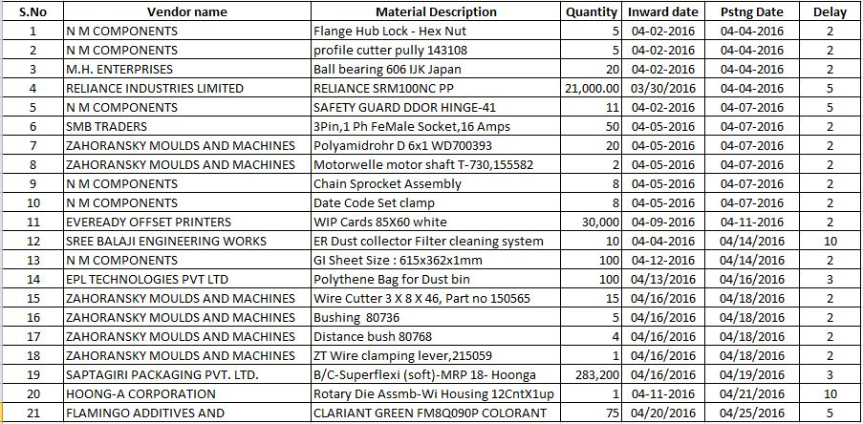

Annexure 1:

Questionnaire for ABC analysis of inventory:

1. What are the Expectations in implementing ABC categorization?
   1. To revise the reorder level and economic order quantity of all store items
2. How many items do you have in the inventory?
   1. 2507
3. What is the total worth of the inventory?
   1. Rs. 2,50,00,000
4. What methodology is currently used in grouping the inventory items?
   1. No grouping done currently
5. What basic information do you record about items?
   1. SKU code, Bin code, Batch code
6. Provide us the Lead Time data of the inventory items.
   1. Given
7. How many transactions do you perform on average monthly?
   1. 6000
8. Provide us the details about the frequency of movement of the inventory and Spare items
   1. To be found from the provided data
9. What is the current reorder level and economic order quantity maintained?
   1. given
10. Does management monitor and approve the write-offs of obsolete and inactive inventories?
    1. yes
11. What percentage of the items are holding inventory in the overall inventory list?
    1. To be found
12. Specify the best features of current system.
    1. NA
13. Specify the deficiencies you find in current system and mention the areas where improvement needed.
    1. NA